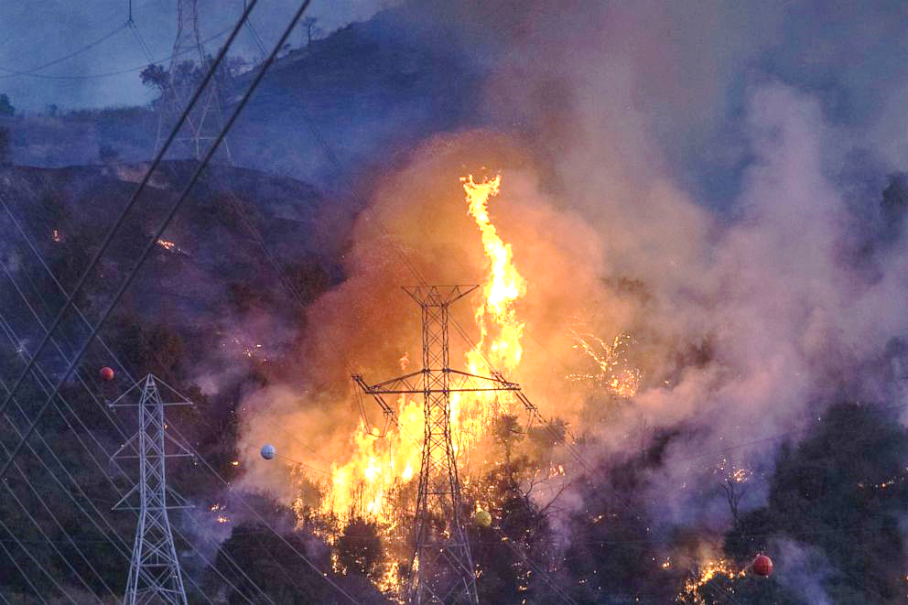
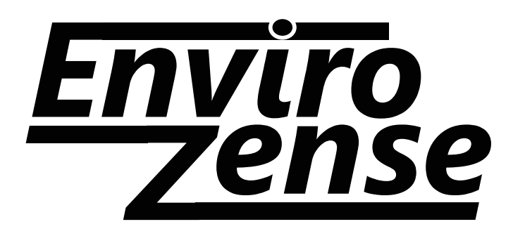
A Simple Sensor Device with Staggering Results in Wildfire Environments
Temperature | Structural Impact
>200°C or 392°F | Decrease in modulus of elasticity
>400°C or 752°F | Decrease in yield strength & Zinc will begin to melt
>600°C or 1112°F | 50% loss in strength and oxidation will occur

By December 18, 2020 there were about 57,000 wildfires compared with 50,477 in 2019, according to the National Interagency Fire Center. More than 10.3 million acres were burned in 2020, compared with 4.7 million acres in 2019. Five of the top 20 largest California wildfires fires occurred in 2020. The extreme temperatures of these wildfires can cause a reduction in structural strength and even melt the zinc off galvanized steel. This can lead to accelerated corrosion, or even the collapse of lattice towers.

EnviroZense is a wireless, heat resistant, temperature and corrosion monitoring sensor that is contained in an electrical enclosure underground at the project site. The patented, EnviroZense unit is simple to install and comprises of corrosion and temperature sensors – one to monitor the wildfire temperatures and the second to monitor the corrosion activity of the bare steel structure below ground. The EnviroZense is configured to collect data routinely, at specific time intervals. The data is wirelessly transmitted by a satellite module for analysis and warns the project owner of abnormal temperature rises before more serious structural problems occur.
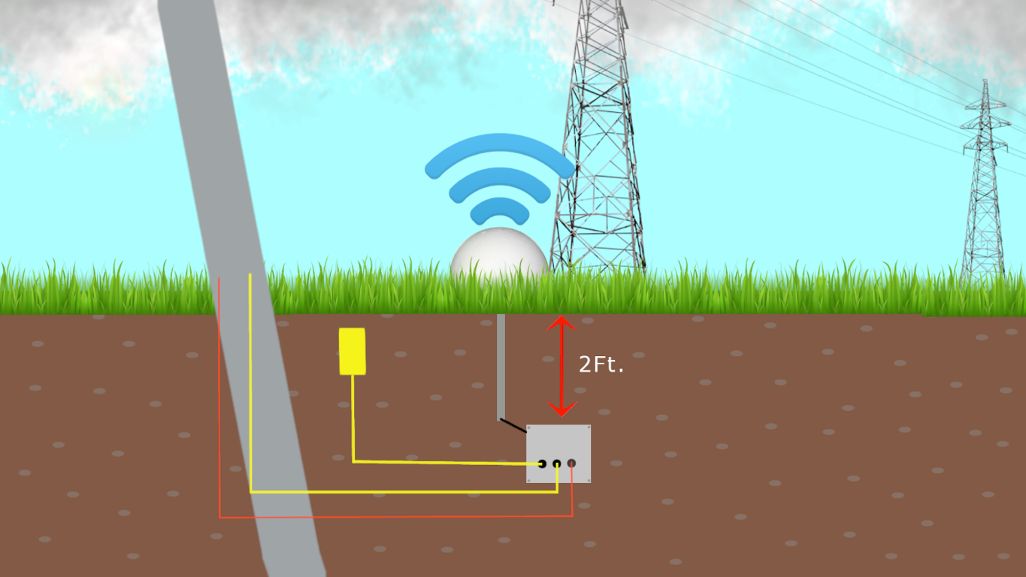
EnviroZense Features:
- Up to 4 temperature sensors
- Up to 4 corrosion sensors
- Helical Satellite antenna w/ heat resistant dome
- Li Batteries w/ 3–5-year life
- Water-tight corrosion resistant container
- Operating temperature -20-1600°F

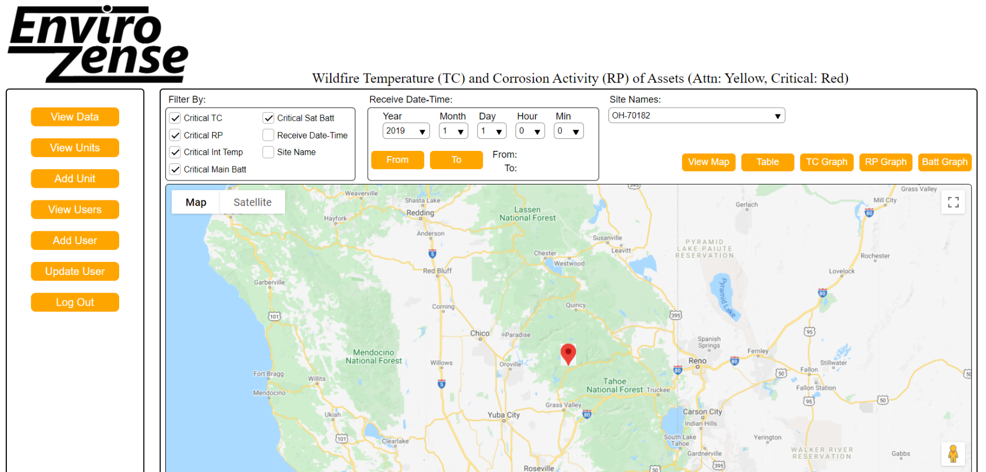
View your data immediately!
The EnviroZense WebView allows you to monitor the temperature and corrosion potential data from each structure in real time. Critical temperatures and corrosion potentials will be highlighted for quick identification, so you know which structures need attention. The EnviroZense WebView can also graph data for a quick and easy way to analyze how long your structures have been exposed to elevated temperatures or corrosive environments.
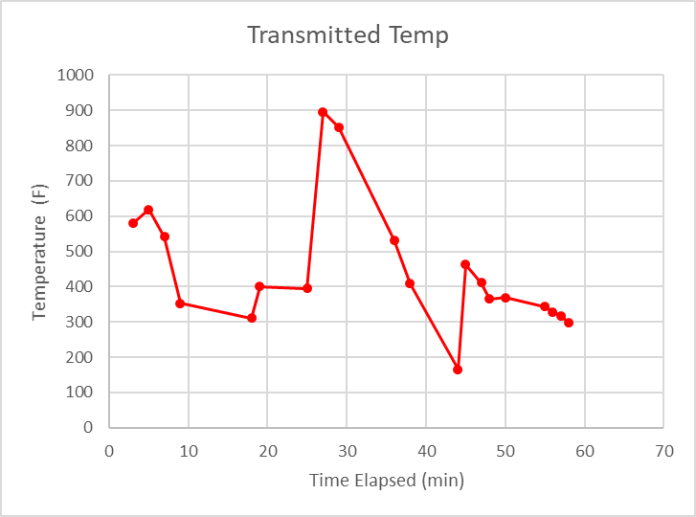
Viewable Data Includes:
- Date and Time of data receipt
- Name of Site Location
- Description of the Structure
- Remaining Battery Voltage
- Internal Temperature of the EnviroZense
- Up to 4 temperature sensor readings
- Up to 4 corrosion sensor readings
- GPS Location of Structure

